


BLM’s Assessment, Inventory, and Monitoring (AIM)

Terrestrial Benchmark Tool User Manual
VERSION 4.0
Produced by BLM National Operations Center – 3/2022

TABLE OF CONTENTS

TABLE OF CONTENTS 2
1. Introduction and Purpose 4
1.1 Purpose 4
1.2 Definitions 4
1.3 Using ArcPro 6
2. Using the ArcGIS Pro Toolbox 6
2.1 Overview 6
2.2 Define Analysis Area 7
2.2.1 Summary 7
2.2.2 Usage 7
2.2.3 Parameters 7
2.2.4 Example 8
2.3 Assign Groups Using Map Selection 9
2.3.1 Summary 9
2.3.2 Usage 9
2.3.3 Parameters 9
2.3.4 Example 10
2.4 Assign Groups by Query 10
2.4.1 Summary 10
2.4.2 Usage 10
2.4.3 Parameters 10
2.4.4 Example 11
2.5 Assign Groups by Polygon 11
2.5.1 Summary 11
2.5.2 Usage 11
2.5.3 Parameters 11
2.5.4 Example 12
2.6 Apply Benchmarks 17
2.6.1 Summary 17
2.6.2 Usage 17
2.6.3 Parameters 17
2.6.4 Example 18
3. Understanding the Tool Outputs 19
3.1 Excel Workbook 19
3.1.1 Raw Data Tab 19
3.1.2 Indicator Summary Tab 19
3.1.3 Reporting Unit Summary Tab 19
3.1.4 Plot Summary Tab 19
3.2 Output Geodatabase 20
3.2.1 Benchmarked points feature class 20
Appendix 1 – Filling out the Monitoring Objectives Spreadsheet 21

1. Introduction and Purpose

1.1 Purpose
The purpose of this document is to describe ow to use the Terrestrial Benchmark Tool version 4, found at the following link: \\blm\dfs\loc\EGIS\ProjectsNational\AIM\AIMDataTools\ArcPro
The terrestrial benchmark tool allows users to:
- Download data from the Terrestrial AIM database for a particular analysis area
- Define benchmark groups and reporting units by plot
- Document benchmarks and monitoring objectives
- Apply benchmarks to the relevant AIM data
- Automate the creation of summary tables of the results
This tool is intended to be used for data analysis using an unweighted/point-counting approach. For example, after all Steps in this Tool have been completed, the summary worksheet will show you which plots and how many plots are meeting or not meeting a certain objective. This can be helpful in your NEPA documents, land health assessments, or simply visualizing the monitoring data that you have in your field office. Keep in mind that a point counting analysis as conducted using this tool does not use any sample design information and therefore does not take into account potential spatial biases. For a more rigorous statistical analysis, contact the NOC to complete a weighted analysis.

1.2 Definitions
Monitoring objectives help translate information to action in natural resource management. These quantitative statements let us know, was the management goal achieved? As outlined in the Developing Monitoring Objectives section of the Monitoring Design Worksheet, monitoring objectives should include, at a minimum:
An indicator
Benchmark for the indicator
A time frame for evaluating the indicator
The reporting unit(s) over which the monitoring results will be reported.
Benchmarks are a key component of every monitoring objective. Benchmarks are indicator values, or ranges of values, that establish desired conditions and are meaningful for management. They are used to compare observed indicator values at assessed points (i.e., monitoring points) to desired conditions. For example, achieving a benchmark value of plant density may tell you that a seeding project was successful; failure to achieve it may trigger reevaluation of seeding methods.
Often, when considering an area with multiple monitoring locations, some amount of failure to achieve a benchmark is acceptable. Natural events such as floods, droughts, fire and disease result in natural variability across a landscape. For that reason, monitoring objectives also include the proportion of the landscape that is required to meet a given benchmark. For example, achieving a benchmark density of plants on 80% of seeded acres can indicate success, even if 20% of the acres did not meet the benchmark value.
Benchmarks, along with associated required landscape proportions, provide a way to objectively operationalize policy statements such as: “take appropriate action” to make “significant progress toward fulfillment” of land health standards.
Setting benchmarks is a necessary but often challenging step. There are two general, valid approaches to setting benchmarks:
Reference or expected conditions (e.g., natural range of variability). This approach assumes that the goal of land management is to maintain or restore ecosystems to minimally or least disturbed conditions. For example, the EPA has partnered with BLM and other agencies to identify a network of “least disturbed” sites. Benchmarks are then defined in terms of departure from the indicator values found at these “reference” sites (reviewed in Hawkins et al. 2010). Similarly, ecological site descriptions describe reference plant communities, and benchmarks can be defined from the attributes of these plant communities (USDA NRCS 1997).
Desired conditions (e.g., habitat criteria). This approach focuses on the ecosystem goods and services that society desires the land to produce, and what range of values for a given indicator will sustain them. For example, the BLM has set a number of benchmarks for sagebrush cover and other vegetation characteristics in order to maintain habitat for the Greater sage-grouse (e.g., Stiver et al. 2015).
Benchmarks will often vary across the landscape. It is important to take these variations into account when setting benchmarks. The goal is to ensure we are comparing assessed sites to those with similar potential, or apples to apples. Thus, similar biophysical areas with similar ecological potential should have similar benchmarks. In contrast, areas with large differences in ecological potential may have large differences in benchmarks. There are numerous approaches for accomplishing this such as ecological site descriptions (USDA NRCS 1997), grouping least disturbed sites by ecoregion or stream size (Hughes et al. 1986; Hawkins et al. 2000 ), or site-specific empirical models (Hill et al. 2013; Olson and Hawkins, 2012).
The key with setting benchmarks and required landscape proportions is to clearly justify the approach that you took. Good resources for setting benchmarks include: existing policy; best professional judgment; paired reference sites; predicted natural conditions; ecological site descriptions, range of variability among reference site networks; and peer-reviewed studies. Often, a combination of these resources will be used. Likewise, the required proportions may follow from a variety of sources including ecological and policy considerations.
A benchmark group is a geographic area or group of monitoring points that have the same benchmark for evaluating the success of a particular monitoring objective. For example, if you have points across your entire field office but want to evaluate a sage grouse habitat objective, only the points that are within sage grouse habitat should be considered for that particular objective. Likewise, the ecoregion, ecological site or stream type, the evaluation area or stream type must be taken into account for determining whether an objective is met when benchmarks vary by ecoregion or ESD.
A reporting unit is a subset of the study area where you need information, such as indicator means and confidence intervals. A study area can have different types of reporting units. Knowing the units ahead of time helps ensure adequate sampling. Reporting units may be different than stratification. Watersheds, allotments, and Greater Sage-grouse habitat units are all examples of reporting units.

1.3 Using ArcPro
The benchmark toolbox is run from an ArcPro project and cannot be run using ArcMap. ArcPro can either be run from your own laptop via a local installation on your C:\\ drive or via the Citrix XenDesktop application to gain access remotely. Accessing ArcPro remotely via Citrix XenDesktop is likely to be much faster while working over the VPN compared to a local installation. To request installation of XenDesktop please submit a BLM remedy ticket as so:
- Navigate to https://blmremedy.blm.doi.net/
- Select “GIS Support” under available requests
- Click the GIS Support radio button
- In “Select the GIS software” search for EGIS and pick either of the two EGIS Citrix Desktop choices
- In “Describe your issue” say Request access to Citrix XenDesktop to use ArcGIS Pro
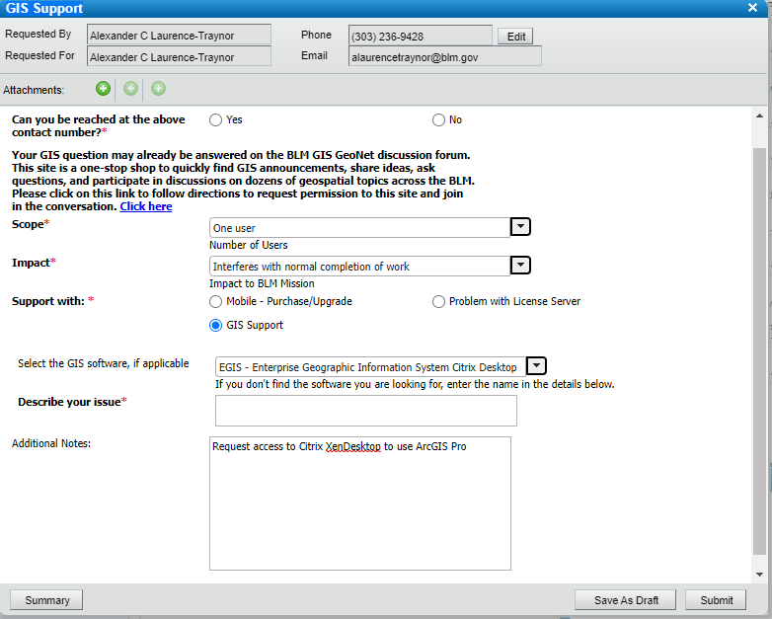

To request an ArcPro license, please follow the guidance found on the Geospatial Gateway Sharepoint here: https://doimspp.sharepoint.com/sites/blm-oc/drs/SitePages/Gateway%20Guidelines.aspx

2. Using the ArcGIS Pro Toolbox

2.1 Overview
The benchmark tool is an ArcGIS Pro toolbox which can be accessed from the AIM Terrestrial ArcGIS Pro Map document found here: \\blm\dfs\loc\EGIS\ProjectsNational\AIM\AIMDataTools\ArcPro\AllTerrestrialLayersAndTables.
Alternatively, the toolbox can be added to an existing ArcPro map by selecting the Add Toolbox button on the Catalog pane and adding the toolbox located here: \\blm\dfs\loc\EGIS\ProjectsNational\AIM\AIMDataTools\ArcPro\Terrestrial Benchmark Tool v4.0
Once added the Toolbox will look like this in the Catalog pane:
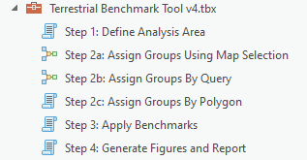
In order to complete these steps, you will need:
- A polygon of your analysis area
- Information to assign benchmark groups. This may be a polygon, a look up table, a field in Terradat (i.e., EcologicalSiteId), or other informative spatial data such as LANDFIRE Biophysical Settings, Ecological Site Groups, Ecoregions etc.,
- A filled in Monitoring Objectives Spreadsheet (unless using any of the default benchmarks)
There are three steps to apply AIM monitoring objectives to terrestrial AIM monitoring locations. These steps should be used sequentially, i.e., you must complete Step 1 prior to Step 2 and Step 2 prior to Step 3. There are several different tools for completing Step 2: Assign Groups – you can use one or a combination of these tools to assign groups, as necessary.

2.2 Define Analysis Area
  - 2.2.1 Summary
Step 1 of the Terrestrial Benchmark Tool v4.0. This tool clips AIM and/or LMF data to a project or analysis area. There is also the option to filter AIM/LMF by the most recent visit to exclude original visits to revisit points as well as download related tables and raw data such as the state species list, species indicators, soil pit details, plot observation etc.,
  - 2.2.2 Usage
- Fill in each of the required parameters. There are descriptions and helpful hints if you click on the information icon next to each parameter.
- Enter the polygon of your analysis area into the tool. This could be a layer already loaded in your map or a file directory pointing to a feature class or shapefile.
- Enter the name of your analysis – this will be used to name the new feature classes the tool creates, don’t use special characters, spaces or start with a number.
- Choose whether or not to include LMF data. LMF (Landscape Monitoring Framework) data is monitoring data collected using a national scale sample design and uses the same core methods as AIM.
- Choose whether or not to restrict to the most recent visit for plots which have been visited more than once. Filtering out older visits may be most appropriate to understanding current condition whereas including older visits will be helpful for understanding trend.
- Choose an output folder. You must have permission to write to this directory. Note that you are creating a new geodatabase that will hold the new data. You are also creating two new feature classes for the reporting unit and the AIM/LMF points. The tool will overwrite a geodatabase in this directory if it has the same name.
- Choose whether to download related tables alongside the indicator data. This may add a considerable amount of time for the tool to finish running so only include tables which are absolutely necessary.
- Click “Run” and let the tool run: it may take a few minutes.
- After the tool has finished running, you’ll notice a few things:
- Two new feature classes have been added to your map. These are the plots that fell within the Analysis area Boundary you just specified and the analysis area polygon.
- If you look back at your output folder, you’ll see a new geodatabase named with your analysis name.
  - 2.2.3 Parameters
Name | Explanation | Data Type
Analysis Area | Polygon or feature class encompassing the analysis reporting area | Feature Layer; Feature Class; Table view; Shapefile
Analysis Name | Name of analysis used for naming output files. No spaces or special characters. | Character String (no spaces or special characters)
Include LMF? | Checking this box will include LMF points. Unchecked will exclude LMF. | Boolean (Yes/No Checkbox)
Restrict to Most Recent Visit? | Checking this box restricts the output feature class to the most recent visit and excludes original visits on revisit points. | Boolean (Yes/No Checkbox)
Output Folder | File path for creating an output geodatabase and results feature classes and spreadsheet. | Folder Path
Related Tables | Checking this box gives the option to download related tables (specified in Tables List) and raw data for the AIM/LMF points within the Analysis Area | Boolean (Yes/No Checkbox)
Tables List | List of related tables to download. “All Tables” will download all related tables and raw data (this may take a long time to download) | Character String (from dropdown list)

  - 2.2.4 Example
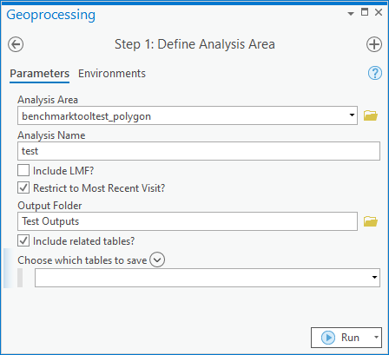

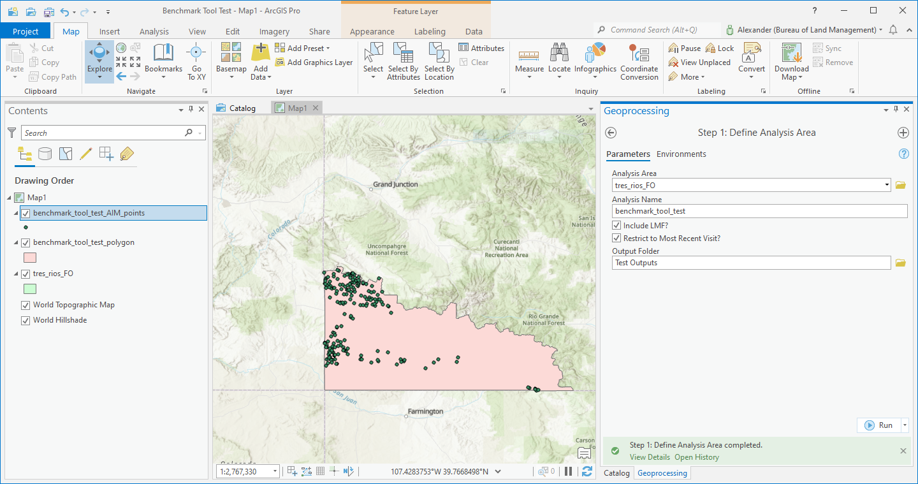

2.3 Assign Groups Using Map Selection
  - 2.3.1 Summary
This tool is the second of three steps in preparing data for the AIM Terrestrial Benchmark Tool. It allows the user to assign benchmark groups or reporting units by selecting points on the map.
  - 2.3.2 Usage
- Make a selection on the points feature class from step 1
- Fill in the parameters: the first parameter should be the feature class that was added to your map in step 1
- Name the group for that selection.
- Specify whether this is a benchmark group or a reporting unit
- Click “Run”, it may take a few minutes
- Check the attribute table for the points you selected – they should be updated with the benchmark group name you used in the tool
- Repeat for remaining benchmark groups
  - 2.3.3 Parameters
Name | Explanation | Data Type
Output Points feature class from step 1 | Select the Group/Reporting Units feature class you created in Step 1 from the drop-down menu. It must be picked from the menu to work. | Feature Layer; Feature Class; Table view;
Benchmark Group or Reporting Unit | The name of the benchmark group or reporting unit you are creating. | Character String (no spaces or special characters)
Type of Group | This parameter specifies which field in the feature class you will be updating. | Value list. Must be either “BenchmarkGroup” or “ReportingUnit”

  - 2.3.4 Example
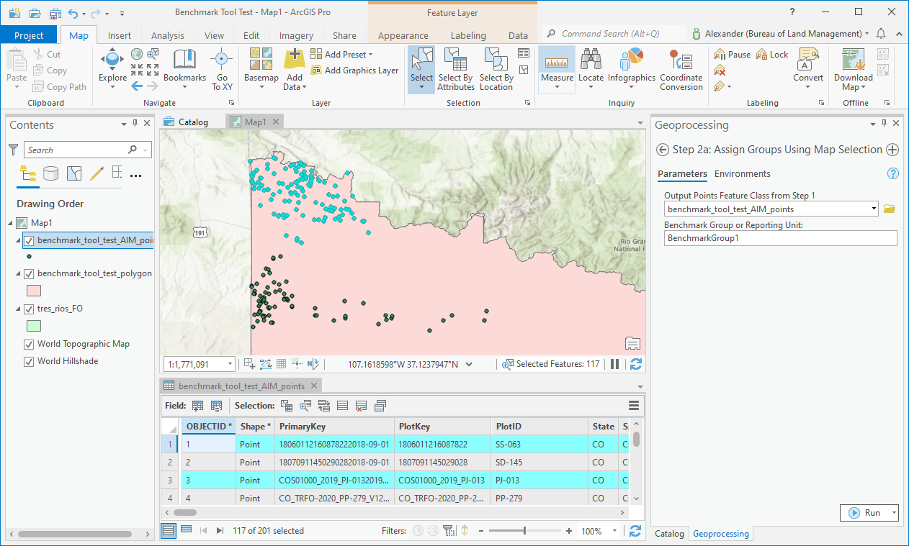

2.4 Assign Groups by Query
  - 2.4.1 Summary
This tool is the second of three steps in preparing data for the AIM Terrestrial Benchmark Tool. It allows the user to assign benchmark groups or reporting units by querying data (e.g., “SiteID = Loamy”, etc.).
  - 2.4.2 Usage
- Select the points feature class you created in Step 1.
- Input the benchmark group or reporting unit name (e.g., Loamy, YellowCreekAllotment, etc.)
- Select the SQL button to write a SQL query
- Define your SQL query. You may want to use the query builder to help with this or see this page for assistance.
- Specify whether this is a benchmark group or a reporting unit you want to update
- Select “Run”.
- Check the attribute table for the points feature class – they should be updated with the benchmark group name you used in the tool.
- Repeat for remaining benchmark groups

  - 2.4.3 Parameters
Name | Explanation | Data Type
Output Points feature class from step 1 | This is the feature class for Groups and Reporting Units you created in Step 1. You must select it from this drop-down for the tool to work. | Feature Layer; Feature Class; Table view;
Benchmark Group or Reporting Unit | Create a unique name for the group/reporting unit. | Character String (no spaces or special characters)
Query Equation | Build a SQL query to select records. | SQL Query
Type of Group | This parameter specifies which field in the feature class you will be updating. | Value list. Must be either “BenchmarkGroup” or “ReportingUnit”

  - 2.4.4 Example
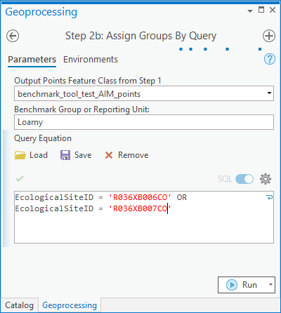

2.5 Assign Groups by Polygon
  - 2.5.1 Summary
This tool is the second of three steps in preparing data for the AIM Terrestrial Benchmark Tool. It allows the user to assign benchmark groups or reporting units from a polygon using a spatial join.
  - 2.5.2 Usage
- Select the points feature class you created in Step 1.
- Select the polygon you will use to define benchmark groups/reporting units. This could be a layer in your map or a file path to a feature class or shapefile.
- If using this polygon to define a single group at a time leave the “Use Polygons Attributes” box unchecked. In the case that you are defining multiple benchmark groups with a single polygon check the “Use Polygons Attributes” box. This will perform a spatial join between your points layer and the group polygon layer. If choosing this option you must also specify the “Group Field”. The group field in your points feature class will be populated with the corresponding value from the benchmark polygon based on location.
- If you left the “Use Polygons Attributes” box unchecked, you must provide a group name. This will be joined to any plots in the points feature class which intersect the group polygon.
- Select the type of group you are assigning – this will either be the benchmark group or reporting unit.
- Click “Run”. This may take several minutes to complete
- Once complete you will see a new layer added to your map with the suffix “_grouped”. Check to attribute table to ensure the relevant fields were filled in correctly.

  - 2.5.3 Parameters
Name | Explanation | Data Type
Output Points feature class from step 1 | Select the Group/Reporting Units feature class you created in Step 1 from the drop-down menu. It must be picked from the menu to work. | Feature Layer; Feature Class; Table view;
Group Polygon | Feature class or layer of a polygon used to classify benchmark groups. | Feature Layer; Feature Class;
Use Polygon's Attributes? | Checking this box will perform spatial join between the points feature class and the group polygon and attribute the Benchmark Group field with the Benchmark Group Field (selected below) from the Group Polygon. If unchecked this tool will perform a spatial join between the points and group polygon and attribute all points which intersect with the Benchmark Group specified below. | Boolean (Yes/No Checkbox)
Benchmark Group/Reporting Unit Name | Name of Benchmark Group to assign to points which intersect the Group Polygon. | Character String
Group Field | Field within Group Polygon which corresponds to the benchmark group or reporting unit. Points which intersect the corresponding features in the Group Polygon will be assigned the value of this field to the Benchmark Group/Reporting Unit field. | Field from Group Polygon
Type of Group | The type of group you are assigning. This will select the corresponding field name in you points layer. | Character String from a list – Either “Reporting Unit” or “Benchmark Group”.

  - 2.5.4 Example
Example 1
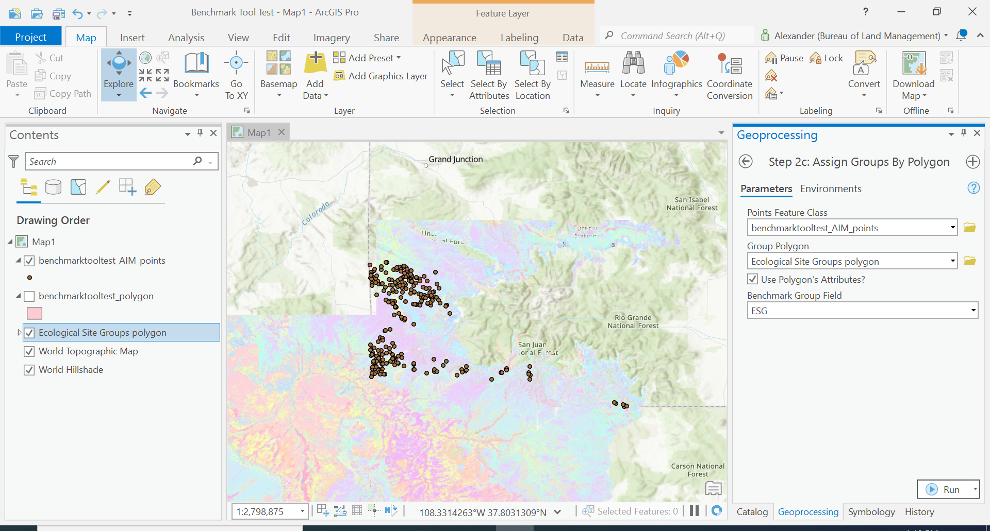
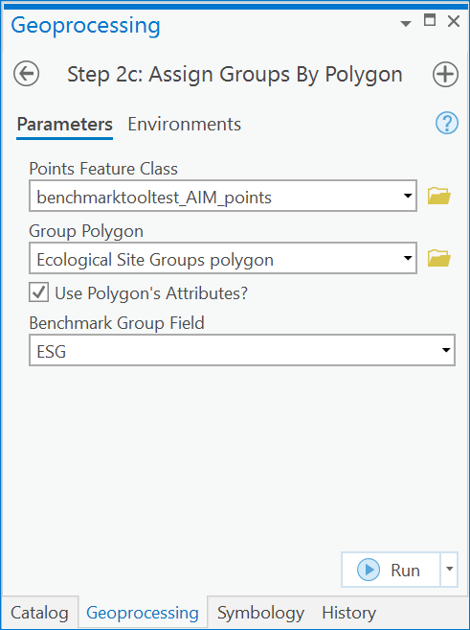
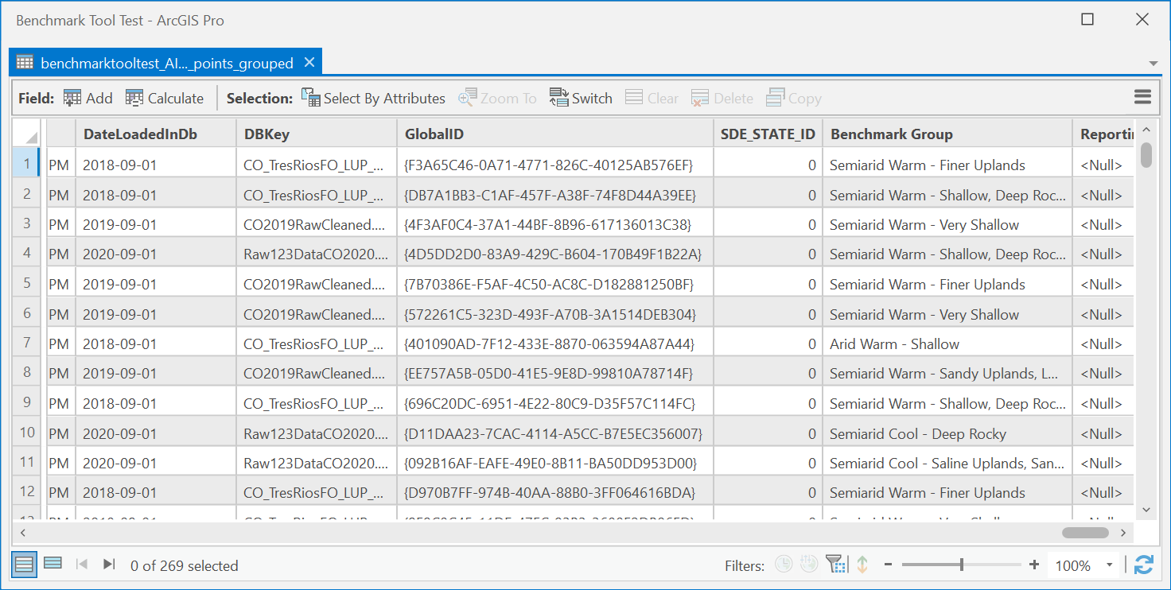

Example 2
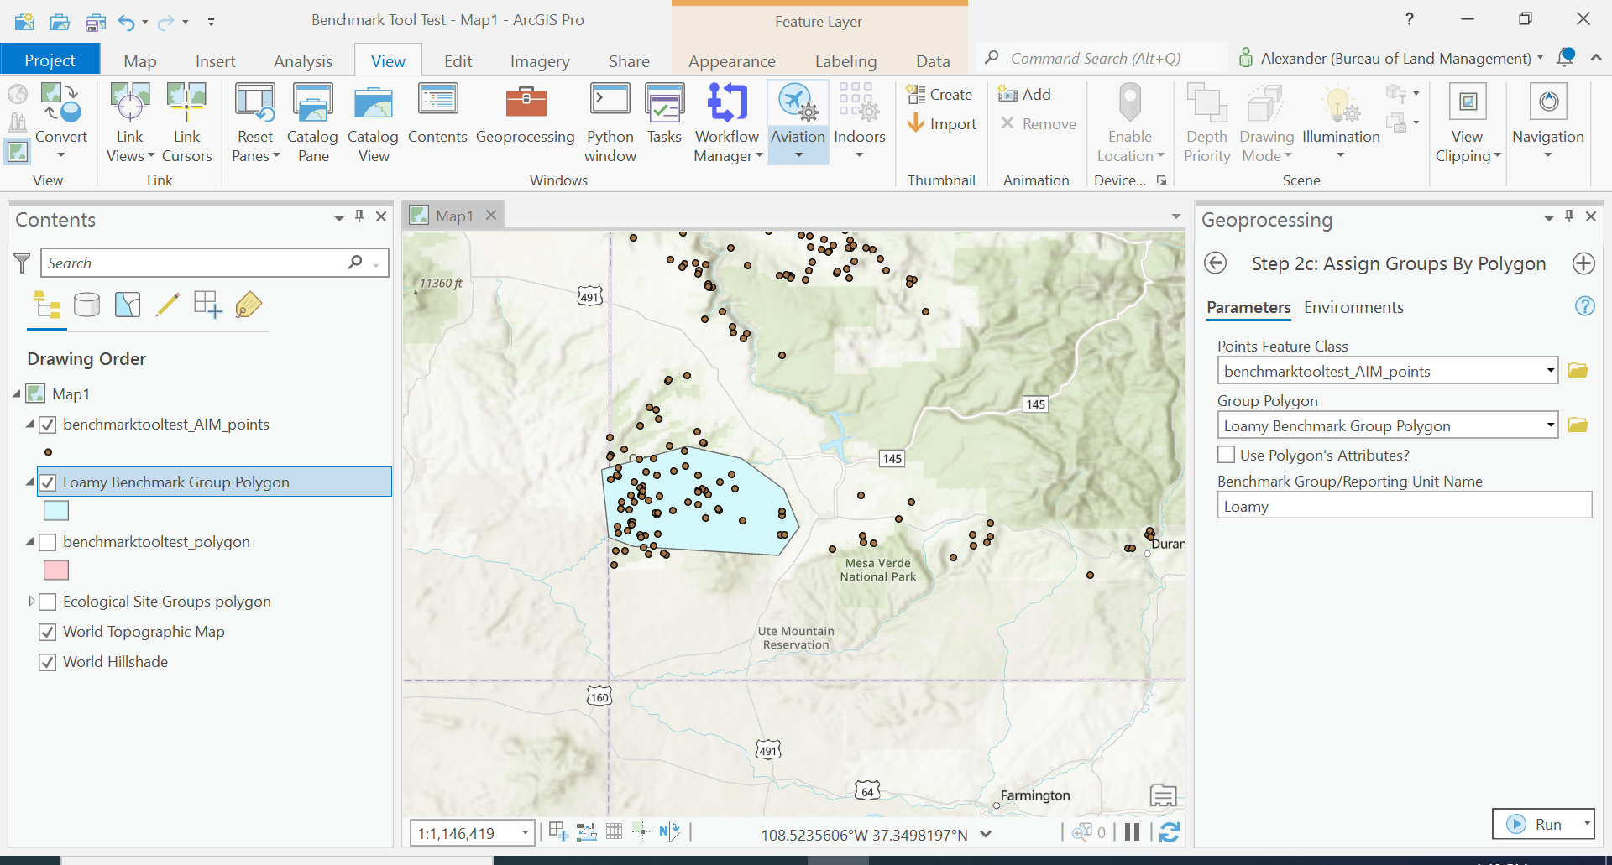
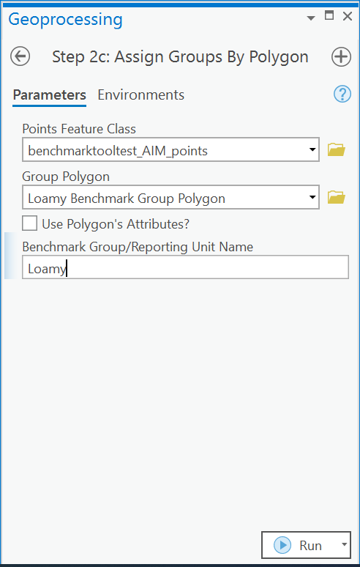
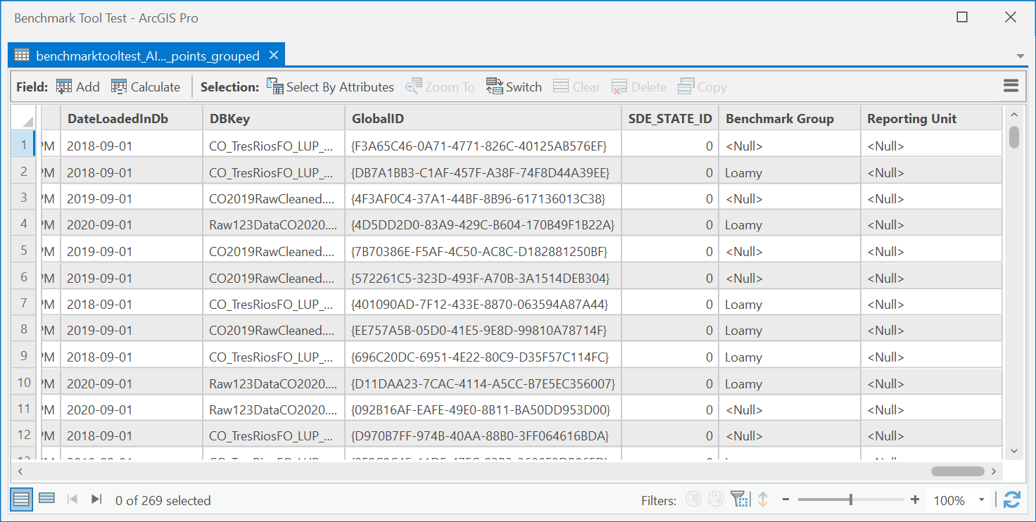

2.6 Apply Benchmarks
  - 2.6.1 Summary
Step 3 of the Terrestrial Benchmark tool v4.0 for applying benchmarks to terrestrial AIM data. This step applies monitoring objectives from the input spreadsheet to the relevant AIM/LMF points based on which benchmark group each point falls in. The outputs are an Excel spreadsheet with summary statistics and a points feature class with the benchmarked points. Outputs are saved in the same directory as the input points feature class.
  - 2.6.2 Usage
- Add the points feature class from Step 2 – this should have all the benchmark groups defined.
- Select whether or not to use default benchmarks. There are several pre-filled monitoring objective spreadsheets which are packaged alongside the benchmark toolbox. These include:
  - National – these are benchmarks used by the NOC for national reporting including benchmarks focused on wildfire risk, water and wind erosion potential, rangeland health ratings, noxious species presence and noxious species abundance.
  - Other individual states may have default benchmarks to use as well
- If using your own monitoring objectives spreadsheet, select its file directory and add to the “Monitoring Objective Spreadsheet” parameter. This file must use the same column structure as the template spreadsheet provided with the toolbox and each column must be filled in with the correct type of data. For a guide on how to fill in this spreadsheet see Appendix I or contact the NOC.
- Click “Run”. The tool may take several minutes to complete.
- Once complete you will see a new feature class added to your map and a new Excel spreadsheet saved in the same directory as your points feature class geodatabase.
- For a more detailed description of the outputs see section 3 of this document “Understanding the Tool Outputs”.
  - 2.6.3 Parameters
Name | Explanation | Data Type
Points feature class from step 2 | The points feature class from step 2 which should contain benchmark groups for each point. | Feature Layer; Feature Class; Table view;
Use Default Benchmarks? | Checking this box allows the user to select existing/default benchmarks for their state. Leave unchecked if uploading your own monitoring objectives spreadsheet. | Boolean (Yes/No Checkbox)
Benchmarks State | Choose a default benchmarks file to use from the relevant state or select “National” for a generic benchmark file. | Character String from dropdown list
Monitoring Objectives Spreadsheet | Spreadsheet containing monitoring objectives for each benchmark group. This spreadsheet needs to have to same format as the default monitoring objectives spreadsheet. | File (must be xlsx, csv, or xls)

  - 2.6.4 Example
Example 1
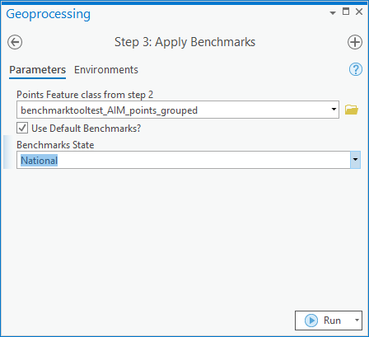

Example 2
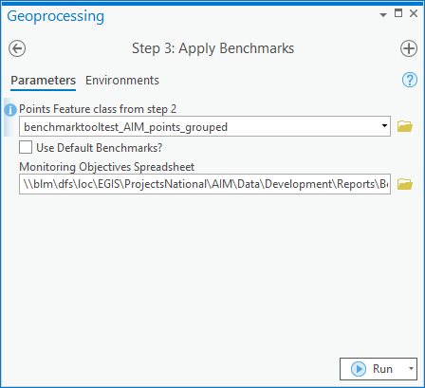

3. Understanding the Tool Outputs

3.1 Excel Workbook
  - 3.1.1 Raw Data Tab
This tab is a tabular version of the output feature class which includes a copy of all the fields present in Terradat as well as the benchmark groups added in step 2 and a field for each objective in the monitoring objectives spreadsheet. Each row corresponds to an individual plot record.
  - 3.1.2 Indicator Summary Tab
This tab provides a simple statistical summary of each of the indicators specified in the monitoring objectives spreadsheet and is split by benchmark group. For each benchmark group the count, mean, standard deviation, minimum, 50th percentile, and maximum values are presented for each indicator.
  - 3.1.3 Reporting Unit Summary Tab
This tab displays the number and percentage of plots in each of the different condition categories for each objective. The plot counts are split by benchmark group, so each row corresponds to the unique combination of objectives, benchmark group and condition category.
  - 3.1.4 Plot Summary Tab
This tab gives a condensed version of the raw data tab which only shows the indicators which were present in the monitoring objectives spreadsheet. These fields include: PrimaryKey, PlotID, Benchmark Group, a field for each indicator, and a field for each objective specifying the condition category that plot fell into.

3.2 Output Geodatabase
  - 3.2.1 Benchmarked points feature class
This is a spatial version of the raw data tab in the output spreadsheet. This contains all of the fields in Terradat as well as fields for benchmark group and fields for each objective present in the monitoring objectives spreadsheet.

Appendix I – Filling out the Monitoring Objectives Spreadsheet

Field Name | Description | Data Type
Objective Name | This is the field name for each objective. For each unique objective name, a new field will be created in the output dataset. The values in this field relate each plot’s condition category, as defined by the relevant benchmarks. | Character string. No special characters or spaces. Cannot start with a number.
Management Question | This is a overarching management goal or question which the monitoring objective relates to. This will often be a Land Health Standard. | Character string
Benchmark Source | The benchmark source describes how the benchmark value was obtained. This could be from a published article, using reference data, ecological site descriptions, best professional judgement or a combination of all these approaches. | Character string
Benchmark Group | The benchmark group is a geographic area or group of monitoring plots which have the same benchmark. His is often related to ecological potential. Common examples include ecological site/group, ecoregion, and MLRA.  The benchmark group must match the benchmark groups specified in Step 2 of the toolbox. | Character string. No special characters or spaces. Cannot start with a number.
Reporting Unit | A reporting unit is a subset of the study area where you need information, such as indicator means and confidence intervals. | Character string. No special characters or spaces. Cannot start with a number.
Lower Limit | The lower numerical limit of the inequality which defines your condition category. | Numeric
LL Relation | The lower limit relation. Either greater than (>), greater than or equal to (>=), or equal to (=). | Dropdown List/Inequality
Indicator | The indicator of interest for benchmark. This must match the indicator field name in Terradat exactly. | Dropdown List
UL Relation | The upper limit relation. Either less than (<), less than or equal to (<=), or equal to (=). | Dropdown List/Inequality
Upper Limit | The upper numerical limit of the inequality which defines your condition category. | Numeric
Unit | The relevant unit for the indicator of interest | Unit
Condition Category | The name of the condition category which applies to the benchmark inequality. Common examples include Meeting, Not Meeting, Suitable, Unsuitable, Marginal, Moderate departure, Extreme departure, Minimal departure etc., | Character string
Proportion Relation | Either less than (<), less the or equal to (<=), greater than (>), greater than or equal to (>=) or equal to. | Inequality
Required Proportion | Describes the required proportion of the reporting unit which should be meeting this objective | Numeric between 0-100

